Linda Mei

Plotter, Salter, and Smoother Graph Results (2 runs)

The plotter graphs both of them look like relatively straight lines. The only visible difference is the line in plotter graph two (10000 points) appears to be more linear than the line in plotter graph one (100 points) because there are more points. For the salter graphs, both of them distort the data, though the values are more visible in graph one compared to graph two. Salter graph one has zig-zag-like values. Similarly, graph two has zig-zag-like values, but there are so many x-values that it is hard to see the specific y-values. For smoother graphs, the graphs were not straight at first since there were not that many points to get a good average. Furthermore, smoother graph two can take more values to the left and right for a "window" than graph one can, resulting in a straighter line. Regardless, if one uses a few points or many points graphically, there would still be similar results to the graphs below.

**Plotter Graph 1**

Equation: y = 6x + 9

Range: 1-100 points

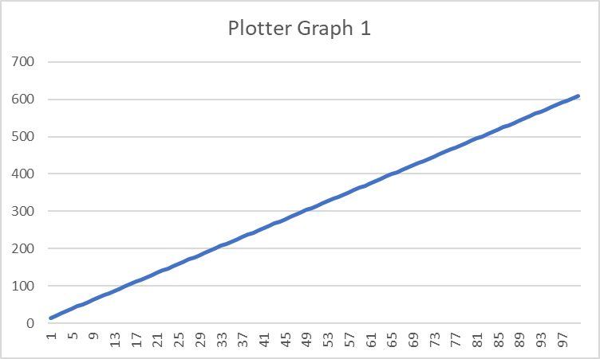

**Salter Graph 1**

Salted the y-values with a random range of 25 to 60

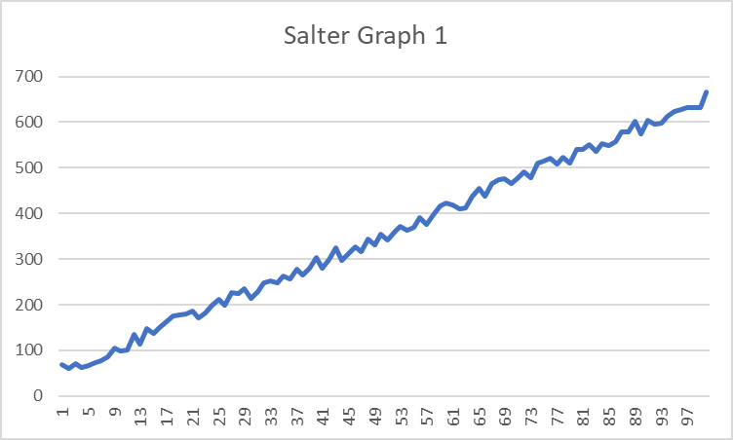

**Smoother Graph 1**

Smoothed the graph (5 points to the left and 5 points to the right of each x-value)

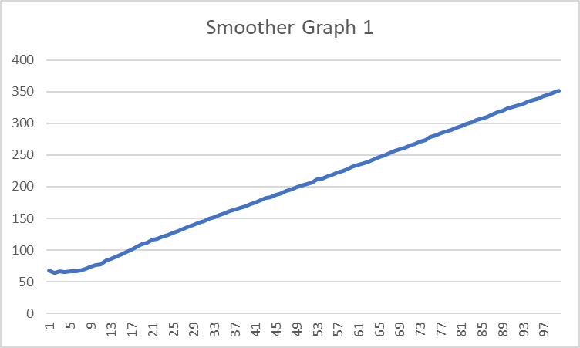

**Plotter Graph 2**

Equation: y = 6x + 9

Range: 1-10000 points

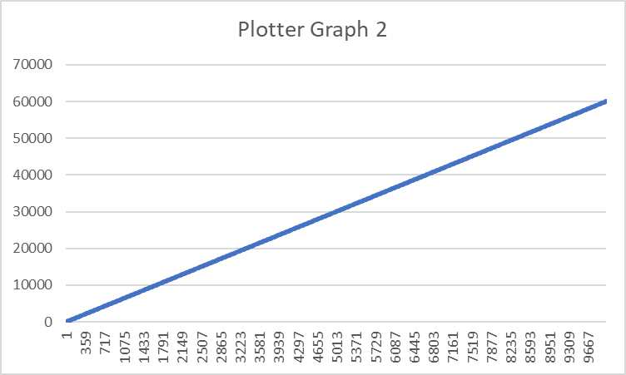

**Salter Graph 2**

Salted the y-values with a random range of 2500 to 7500

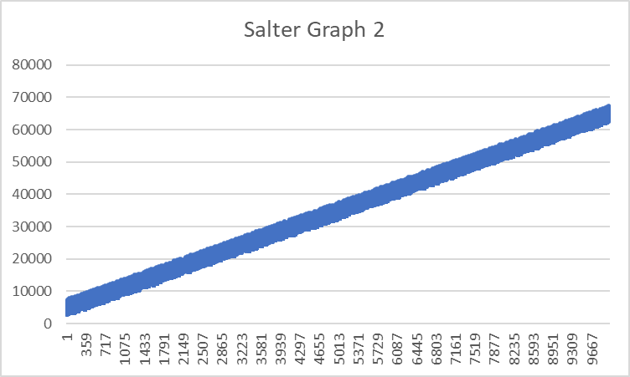

**Smoother Graph 2**

Smoothed the graph (6000 points to the left and 6000 points to the right of each x-value)

